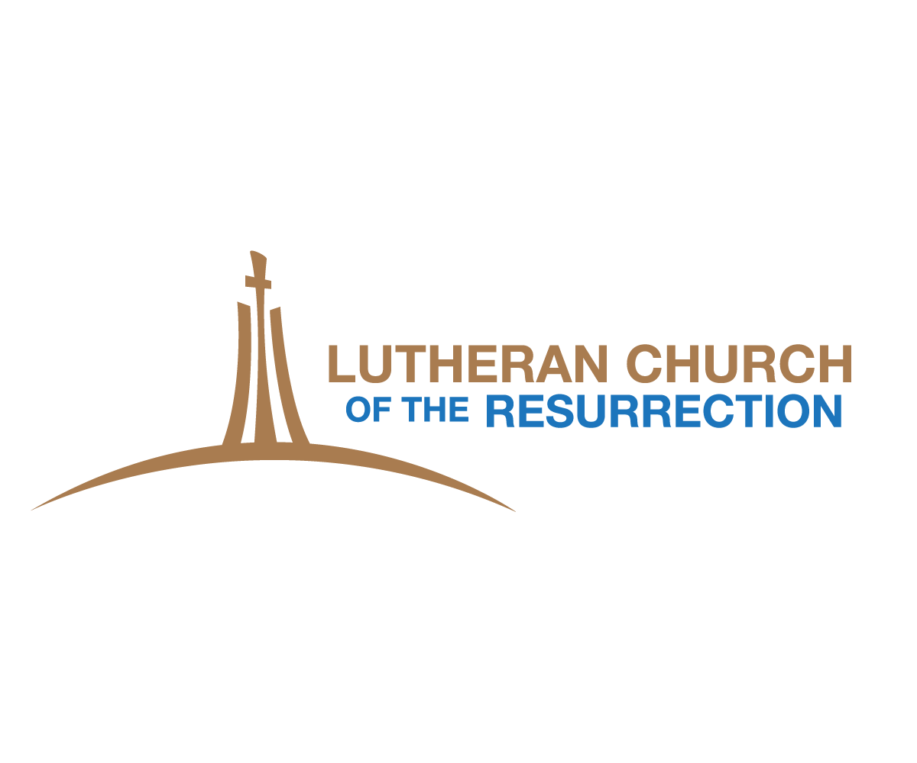

10th Grade Confirmation Faith Statement

- Please place your name and contact information on your paper.
- Faith Statements should be about 1-2 pages in length, typed using regular font size 12 point.
- Please use complete sentences, with specific examples. Elaborate as much as possible.
- Please take time to pray about your reflections before you write your reflections on your faith statement.
- Please choose a favorite bible verse(s) for your confirmation day & beyond
Use the following questions to get ideas:

- How would you describe God to a friend at school?
- How has your relationship with Jesus changed from Sunday school through today? Why does Jesus matter in your life?

- When have you experienced The Holy Spirit at work in your life and what was it like?

- What was one of the most memorable moments in your confirmation journey?
- How does your faith make a difference in your daily life?
- Will you feel differently once you are confirmed?
- How do you see yourself being involved with the church now and in the future?
Just a reminder….your faith statement should be completed by October 14th and turned into Pastor Karen. You must also complete a one hour conversation meeting with Pastor Karen during the 2 weeks before Confirmation Sunday. This conversation meeting is for the confirmand, with a parent or guardian also in attendance.

Please sign-up on Pastor Karen’s office door for you conversation meeting time.

